Steps to Create an IAM User in AWS
1. Go to AWS Console
- Open your browser and visit: https://aws.amazon.com/console/
- Click Sign in to Console.
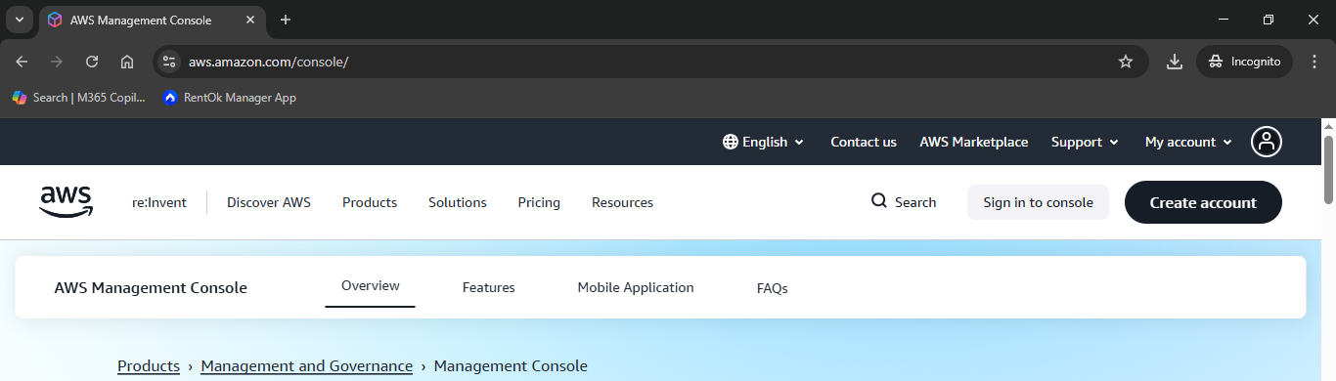
2. Sign in as Root User
- Choose Root user.
- Enter your root email address → click Next.
- Enter your password → click Sign In.

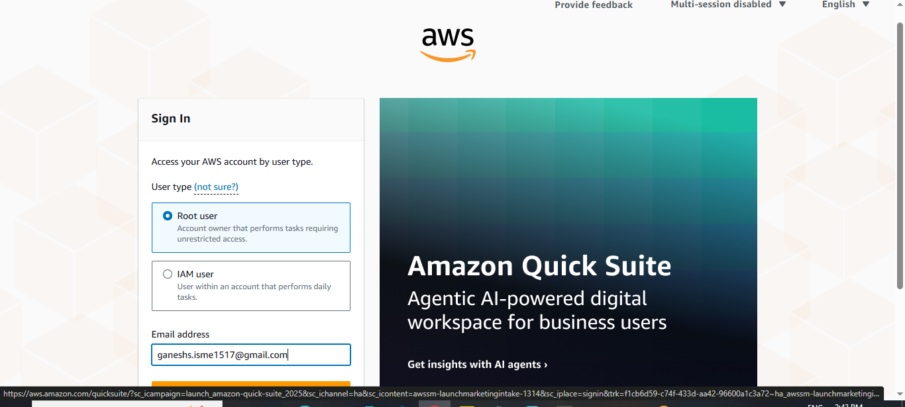

3. Open IAM Service
- After the dashboard opens, in the search bar, type IAM.
- Click IAM service.

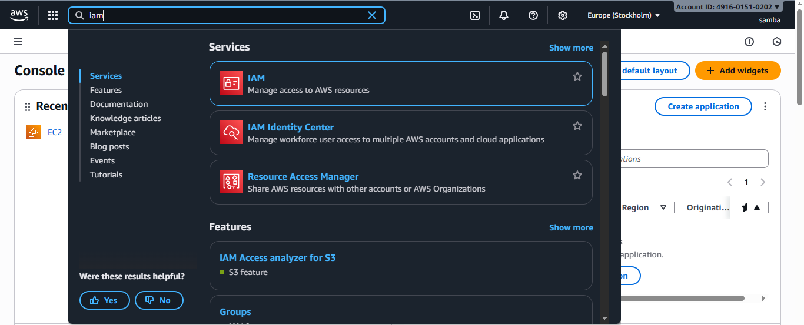
4. Create a New IAM User
- In the left sidebar, go to Access management → Users.
- Click Create user
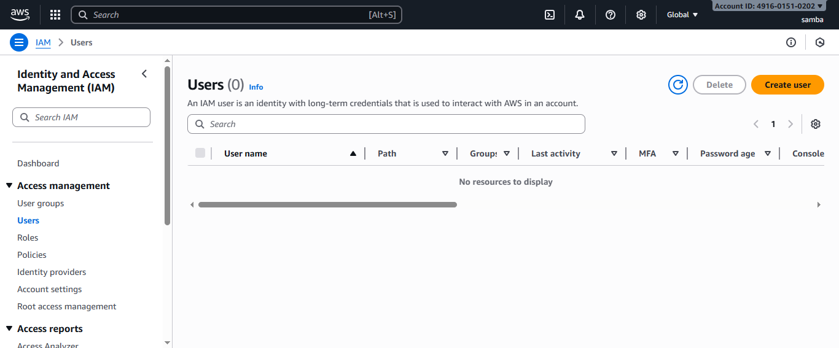

5. Set User Details
- Enter a username for the new IAM user.
- Scroll down to Console access.
- Turn ON Provide user access to the AWS Management Console.
- Choose Custom password.
- Enter the password you want.

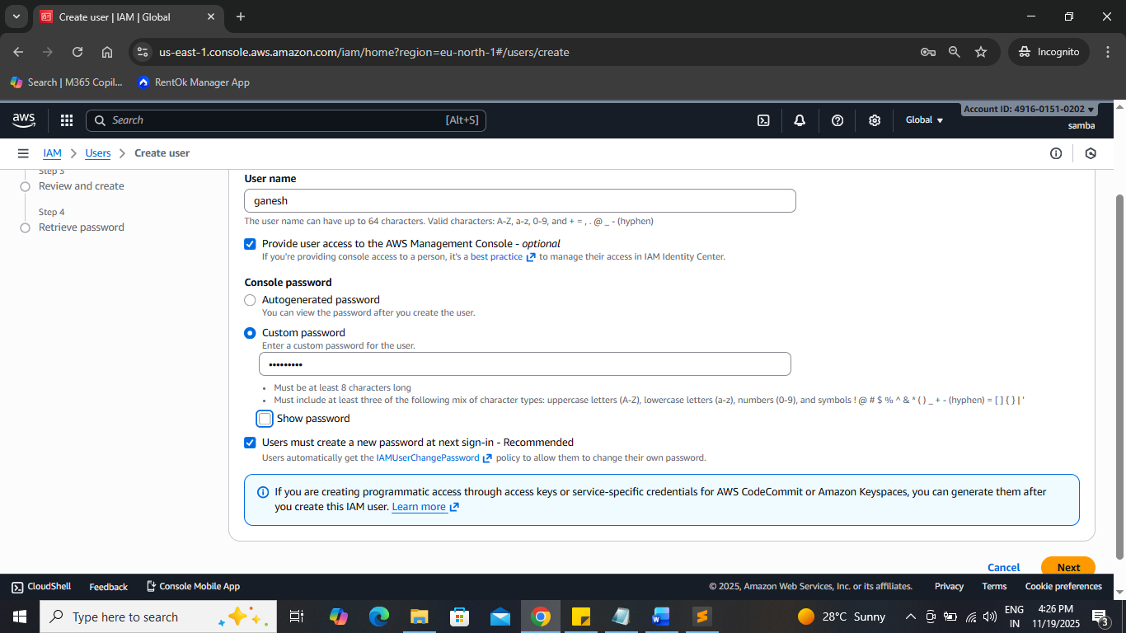

6. Assign Permissions
- Select Set permissions → choose Attach policies directly.
- Search for AdministratorAccess.
- Select the AdministratorAccess policy.
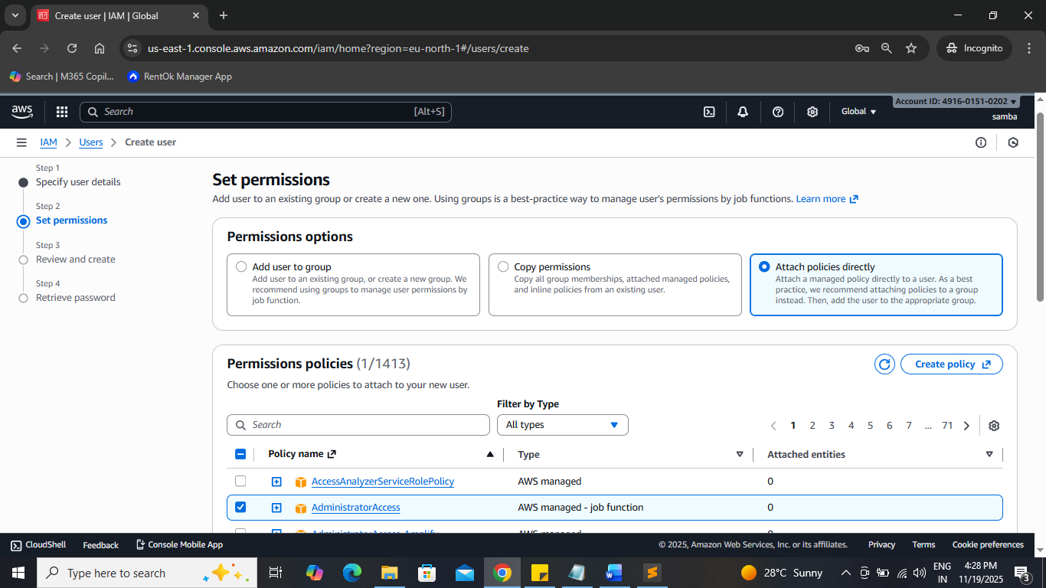

7. Review & Create
- Review all details.
- Click Create user.
- You will see User created successfully.
- Click Return to users list.

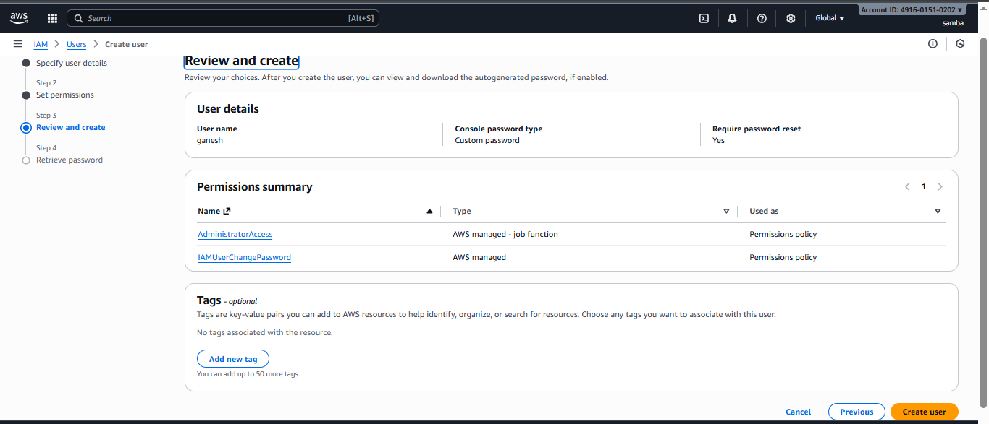

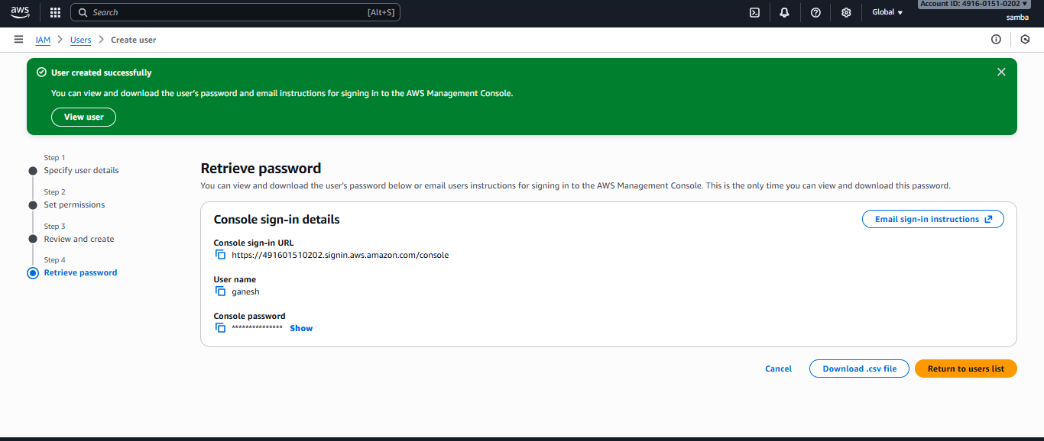

8. Sign In Using the IAM User
- Open AWS console again: https://aws.amazon.com/console/
- Click Sign in to Console
- Enter your Account ID.
- Enter the IAM username.
- Enter the password you set.

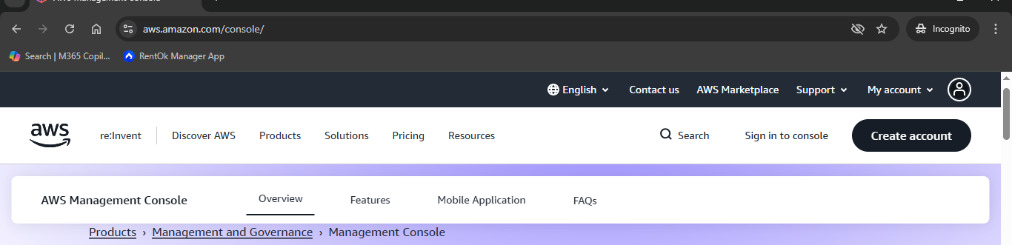

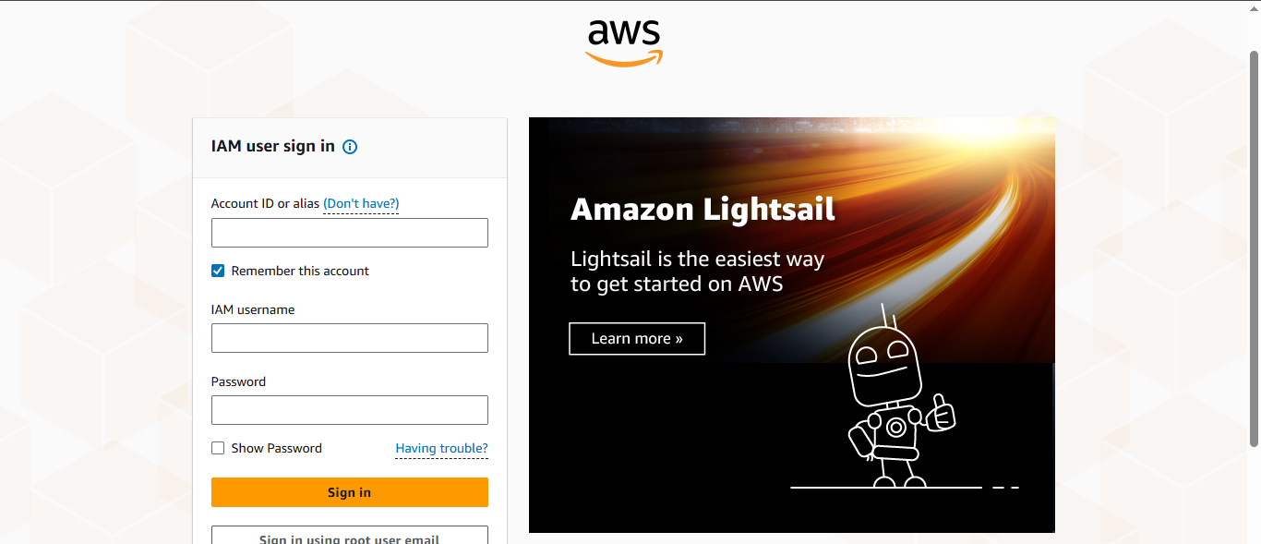

9. Reset Password (First Login)
- On first login, AWS will ask to reset the password.
- Enter a new password and confirm.
- Password updated successfully.
- Click Continue to Sign In.
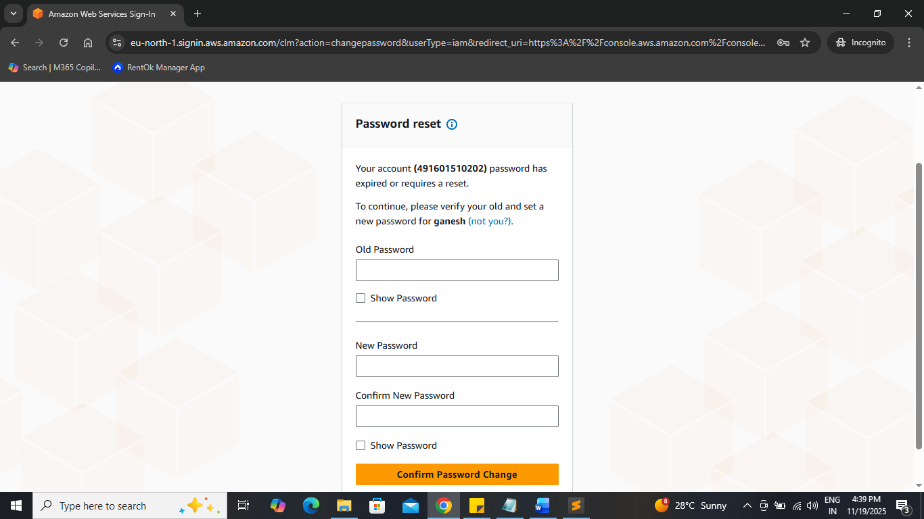

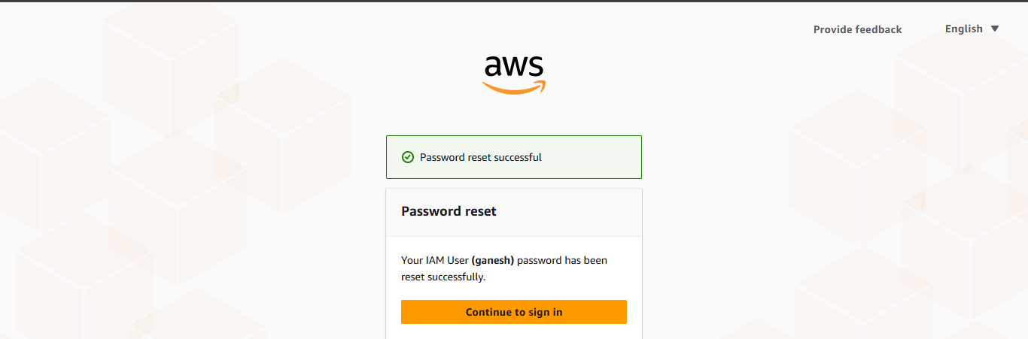

10.IAM user sign in
- Enter Account ID
- Enter IAM Username
- Enter Password
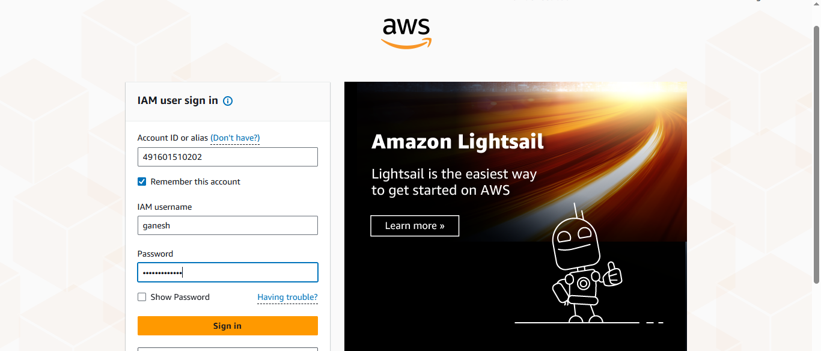
11. IAM User Dashboard Opened
- After successful login, the IAM user dashboard will open
